Site: 036
Latitude: 55.31521
Longtitude: -162.5974
Dates Surveyed: 8/4 - 8/6/2025
Anadromous fish species captured: Coho Salmon, Dolly Varden, Sockeye Salmon
Notes: Sampled on the ground on 8/5/2025. Flowing channel is incised with quality fish habitat.. Substrate is gravel and rock, with overhanging vegetative cover on banks. Captured Coho salmon, Dolly Varden, threespine stickleback, and slimy sculpin.

Photographs

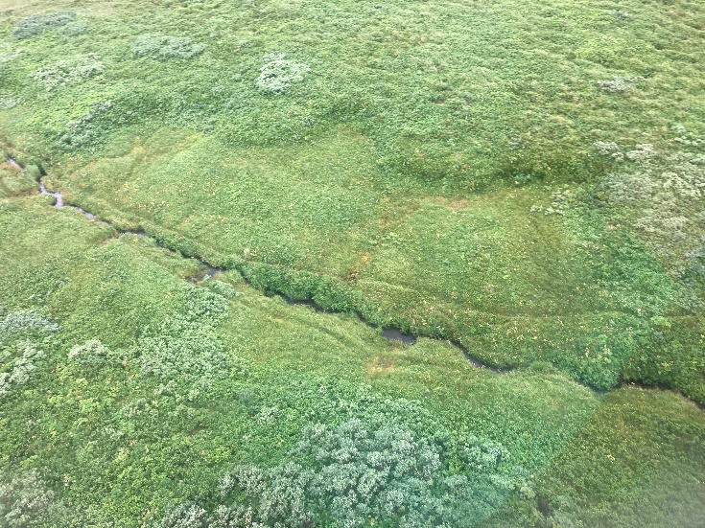 | 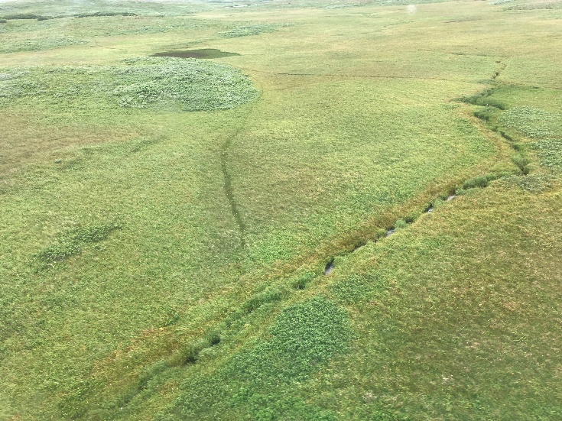
Photo looking north, stream flowing from left to right. | Photo looking northeast, stream flowing from left to right.
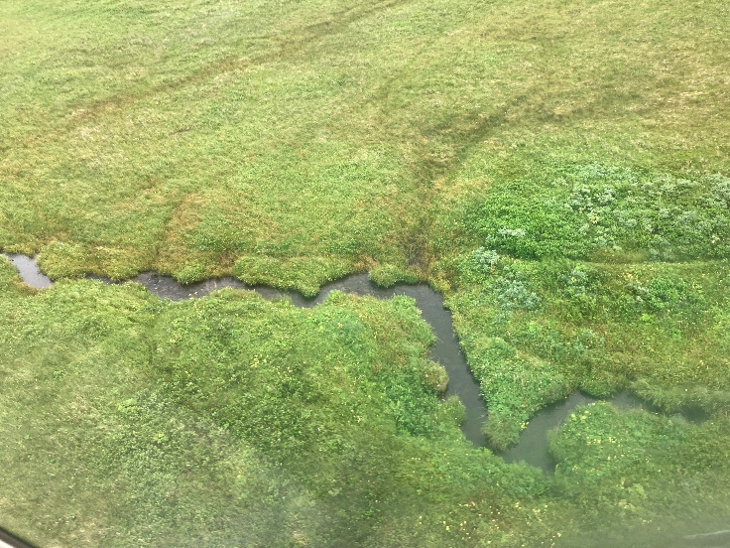 | 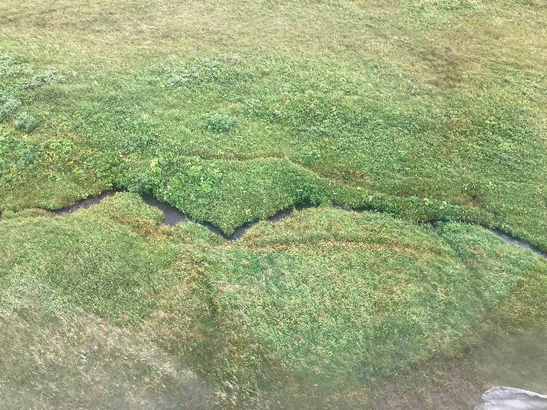
Photo looking northeast, stream flowing from left to right. | Photo looking northeast, stream flowing from left to right.

Photographs

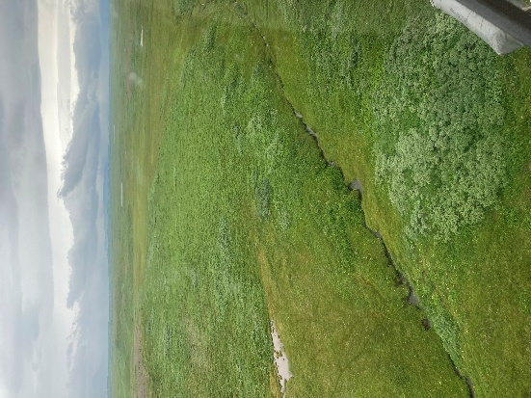 | 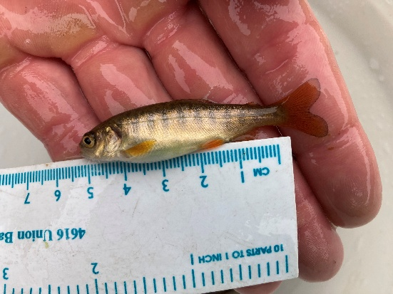
Photo looking upstream to the east. | Juvenile Coho Salmon captured at Stream Crossing 036.
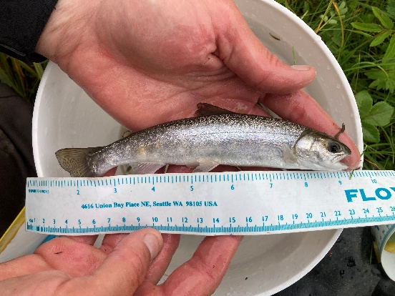 | 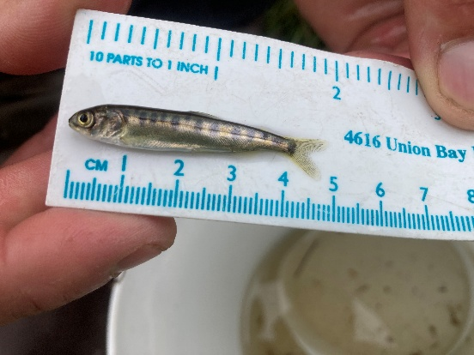
Juvenile Dolly Varden captured at Stream Crossing 036. | Juvenile Sockeye Salmon captured at Stream Crossing 036.

